|  |
| --- |
| **Title Of Project** |
| Clinic Management System |

|  |  |
| --- | --- |
| Student Name | ID |
| Sohair Ashraf | 221001867 |
| menna mosed | 221001273 |
| Nermeen Hanea Ali | 221002201 |
| mohammed sayed | 231002190 |

1. Design Of The Database

Design Of The Database Clinic Management system

The Database include Entities and Attributes which are:

(1)Entity: Department.

Attributes: Department-ID, Name, Description.

(2)Entity: Clinic.

Attributes: Clinic-ID, Name, Address.

(3)Entity: Doctor.

Attributes: Doctor-ID, name, Phone number, Address

(4)Entity: Patient.

Attributes: ID, name, Phone number, address ,birth date, Job.

(5)Entity: Appointment

Attributes: Appointment-ID, date, Start time, end time, Cost, Status, Patient diagnosis.

1. Business Rules

**(1) Department-Clinic**

* Each clinic belongs to only one Department.
* Each Department can have Multiple Clinics.
* **Participation**: Mandatory on both sides.
* **Explanation**: Every Department must be associated with at least one clinic, a clinic must be associated with one Department.

**(2)Doctors-Department**

* Each Department have many Doctors.
* Each Doctor works on one Department.
* **Participation**: optional on Department side and Mandatory on Doctor Side.
* **Explanation**: A Department may have multiple Doctors working under it, but it is Possible for a department to have no Doctors For example: if it is a new Department yet to hire Staff.

**(3) Appointment-Doctor**

* Each Appointment is associated with exactly one doctor To Treat Patient.
* Each Doctor Can Have Multiple appointments with Different Patients.
* **Participation** : Mandatory For Doctor and Appointment
* **Explanation**: Every doctor must have appointments Scheduled, but An appointment Cannot exist without being associated with a doctor.

**(4)Patient-Appointment**

* Each Appointment is associated with exactly one Patient
* Each Patient can have Multiple appointments over time
* **Participation**: Mandatory For Patient and Appointment
* **Explanation**: Every appointment must be associated with a Patient, and each Patient can have only one appointment at a time

1. 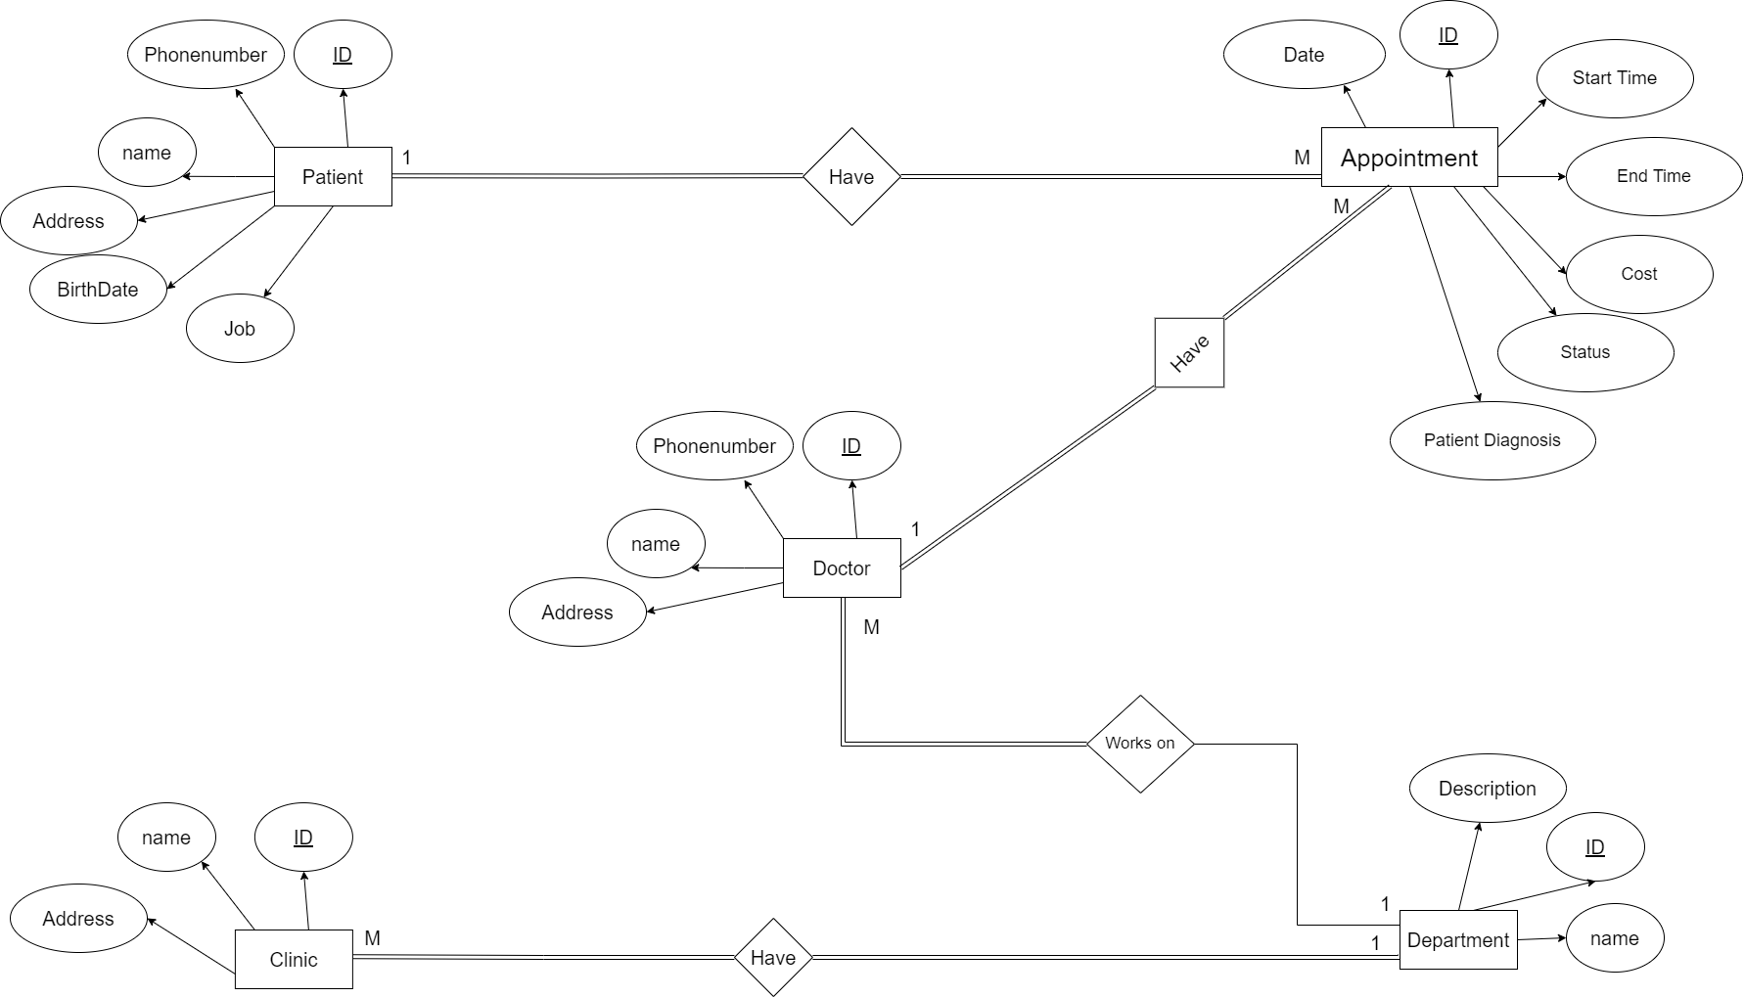ERD Diagram
2. Relational Schema

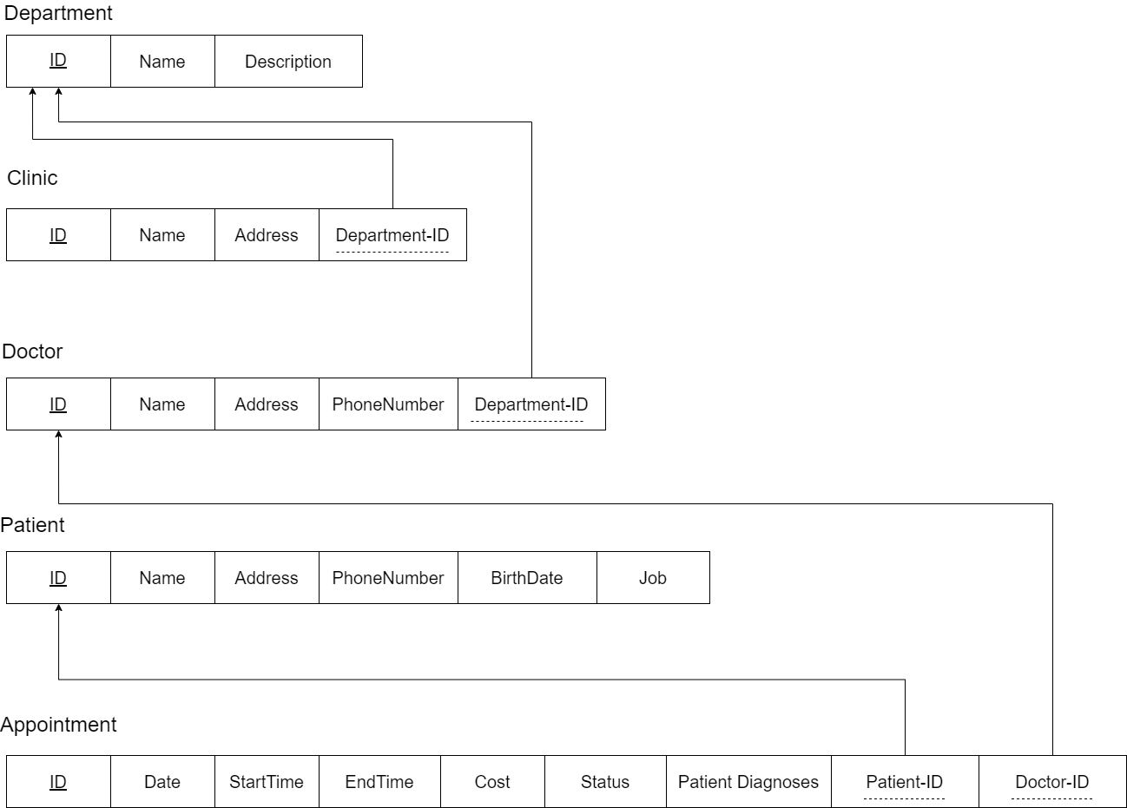

1. MySql Codes

-- Create Department table

CREATE TABLE Department (

ID INT AUTO_INCREMENT PRIMARY KEY,

Name VARCHAR(150),

Description VARCHAR(300)

);

-- Create Clinic table

CREATE TABLE Clinic (

ID INT PRIMARY KEY,

Name VARCHAR(150),

Address VARCHAR(300),

Department_ID INT,

FOREIGN KEY (Department_ID) REFERENCES Department(ID)

);

-- Create Doctor table

CREATE TABLE Doctor (

ID INT PRIMARY KEY,

Name VARCHAR(150),

Phone_Number VARCHAR(20),

Address VARCHAR(300),

Department_ID INT,

FOREIGN KEY (Department_ID) REFERENCES Department(ID);

-- Create Patient table

CREATE TABLE Patient (

ID INT PRIMARY KEY,

Name VARCHAR(150),

Phone_Number VARCHAR(20),

Address VARCHAR(300),

Birth_Date DATE,

Job VARCHAR(150)

);

-- Create Appointment table

CREATE TABLE Appointment (

Appointment_ID INT AUTO_INCREMENT PRIMARY KEY,

Date DATE,

Start_Time TIME,

End_Time TIME,

Cost DECIMAL(12, 2),

Status ENUM('Scheduled', 'In Progress', 'Postponed'),

Patient_Diagnosis VARCHAR(270),

Patient_ID INT,

Doctor_ID INT,

FOREIGN KEY (Patient_ID) REFERENCES Patient(ID),

FOREIGN KEY (Doctor_ID) REFERENCES Doctor(ID)

);

-- Insert sample data into Department table

INSERT INTO Department (Name, Description) VALUES

('Cardiology', 'Deals with heart-related issues'),

('Pulmonology', 'Deals with respiratory system disorders'),

('Hematology', 'Deals with blood-related disorders'),

('Allergy and Immunology', 'Deals with immune system disorders and allergies'),

('Geriatrics', 'Deals with medical care of elderly individuals'),

('Infectious Diseases', 'Deals with infectious diseases and their treatment'),

('Physical Medicine and Rehabilitation', 'Deals with physical therapy and rehabilitation'),

('Anesthesiology', 'Deals with anesthesia and pain management'),

('Pediatrics', 'Deals with medical care of infants, children, and adolescents'),

('Dermatology', 'Deals with skin-related issues'),

('Neurology', 'Deals with nervous system disorders'),

('Orthopedics', 'Deals with musculoskeletal system disorders');

-- Insert sample data into Clinic table

INSERT INTO Clinic (ID, Name, Address, Department_ID) VALUES

(1111, 'Pulmonology Clinic', '1111 Cedarwood St, Nevada, US', 1),

(2222, 'Hematology Center', '1212 Birchwood St, New York, US', 2),

(3333, 'Allergy and Immunology Clinic', '1313 Elmwood Ave, Kansas, US', 3),

(4444, 'Geriatric Care Center', '1414 Maple Ave, Hawaii, US', 4),

(5555, 'Infectious Diseases Clinic', '1515 Oak Ave, Montana, US', 5),

(6666, 'Rehabilitation Center', '1616 Cedar Ave, New Jersey, US', 6),

(7777, 'Anesthesia Clinic', '1717 Birch Ave, Ohio, US', 7),

(8888, 'Pediatric Care Center', '404 Cedar St, Texas, US', 8),

(9999, 'Dermatology Clinic', '505 Birchwood St, New York, US', 9),

(1010, 'Neurology Center', '606 Elmwood Ave, Kansas, US', 10),

(1112, 'Orthopedic Clinic', '707 Maple Ave, Hawaii, US', 11),

(1212, 'Heart Health Center', '808 Oak Ave, Montana, US', 1);

-- Insert sample data into Doctor table

INSERT INTO Doctor (ID, Name, Phone_Number, Address, Department_ID) VALUES

(15995, 'Dr. Thomas', '234-567-8901', '789 Oakwood St, Nevada, US', 1),

(14789, 'Dr. Hernandez', '345-678-9012', '234 Pinecrest St, Nevada, US', 2),

(12369, 'Dr. Moore', '567-890-1234', '567 Cedarwood St, New York, US', 3),

(12529, 'Dr. Martin', '678-901-2345', '890 Birchwood St, New York, US', 4),

(12528, 'Dr. Jackson', '901-234-5678', '123 Elmwood Ave, New York, US', 5),

(12473, 'Dr. Thompson', '123-456-7890', '456 Maple Ave, Hawaii, US', 6),

(98746, 'Dr. White', '234-567-8901', '789 Oak Ave, Hawaii, US', 7),

(56324, 'Dr. Lopez', '345-678-9012', '123 Cedar Ave, Texas, US', 8),

(12523, 'Dr. Israa', '385-688-9812', '1618 Cedar Ave, New Jersey, US', 9),

(11111, 'Dr. Kim', '456-789-0123', '345 Elmwood St, New York, US', 10),

(12121, 'Dr. Patel', '567-890-1234', '678 Maple Ave, Hawaii, US', 11),

(13131, 'Dr. Lee', '678-901-2345', '789 Oak Ave, Montana, US', 1);

-- Insert sample data into Patient table

INSERT INTO Patient (ID, Name, Phone_Number, Address, Birth_Date, Job) VALUES

(12527, 'Michael White', '111-222-3333', '101 Maple St, Nevada, US', '1980-01-01', 'Engineer'),

(92346, 'Richard Thompson', '444-555-6666', '202 Oak St, Hawaii, US', '1990-05-15', 'Teacher'),

(82345, 'Jennifer Jackson', '777-888-9999', '303 Pine St, Texas, US', '1975-10-20', 'Nurse'),

(78360, 'Patricia Martin', '222-333-4444', '404 Cedar St, Texas, US', '1988-03-05', 'Doctor'),

(61213, 'Mary Moore', '555-666-7777', '505 Walnut St, Texas, US', '1982-07-12', 'Lawyer'),

(51516, 'Charles Hernandez', '888-999-0000', '606 Birch St, Montana, US', '1995-12-30', 'Artist'),

(41819, 'Linda Garcia', '111-484-5885', '707 Elmwood St, Montana, US', '1970-08-25', 'Dentist'),

(85258, 'Layla Garcia', '333-224-5225', '707 Elmwood St, Ohio, US', '1970-08-25', 'Engineer'),

(96369, 'John Garcia', '222-774-5775', '707 Elmwood St, Ohio, US', '1970-08-25', 'Engineer'),

(77474, 'William Brown', '111-333-5555', '808 Pine St, Kansas, US', '1985-09-15', 'Architect'),

(88585, 'Elizabeth Scott', '222-444-6666', '909 Elm St, Hawaii, US', '1992-08-19', 'Librarian'),

(99696, 'James Davis', '333-555-7777', '1010 Cedar St, New York, US', '1978-11-22', 'Pharmacist');

-- Insert sample data into Appointment table

INSERT INTO Appointment (Date, Patient_ID, Doctor_ID, Start_Time, End_Time, Cost, Status, Patient_Diagnosis) VALUES

('2023-09-01', 12527, 15995, '10:00:00', '11:00:00', 100.00, 'Scheduled', 'Fatty Liver'),

('2024-06-30', 92346, 12523, '11:30:00', '12:30:00', 240.00, 'In Progress', 'Asthma'),

('2024-07-21', 92346, 56324, '13:30:00', '14:30:00', 250.00, 'Postponed', 'Anemia'),

('2024-08-03', 61213, 56324, '15:30:00', '16:30:00', 260.00, 'Scheduled', 'Allergic Reaction'),

('2024-09-11', 12527, 98746, '10:30:00', '11:30:00', 270.00, 'In Progress', 'Elderly Care'),

('2024-10-02', 51516, 98746, '12:30:00', '13:30:00', 280.00, 'Postponed', 'Infectious Disease Treatment'),

('2024-11-19', 41819, 12473, '14:30:00', '15:30:00', 290.00, 'Scheduled', 'Fatty Liver'),

('2024-12-10', 85258, 12473, '16:30:00', '17:30:00', 300.00, 'In Progress', 'Fatty Liver'),

('2024-12-10', 82345, 12473, '17:30:00', '18:30:00', 300.00, 'Postponed', 'Fatty Liver'),

('2024-12-10', 96369, 12473, '18:30:00', '19:30:00', 300.00, 'In Progress', 'Fatty Liver'),

('2024-07-25', 77474, 11111, '09:00:00', '10:00:00', 200.00, 'Scheduled', 'Migraine'),

('2024-08-19', 88585, 12121, '11:00:00', '12:00:00', 220.00, 'In Progress', 'Skin Rash');

1. Queries

SELECT Patient.Name

FROM Patient

JOIN Appointment ON Patient.ID = Appointment.Patient_ID

WHERE Appointment.Patient_Diagnosis = 'Fatty Liver'

AND Appointment.Date >= DATE_SUB(CURDATE(), INTERVAL 1 YEAR);

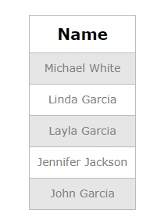

SELECT Clinic.Address

FROM Clinic

JOIN Department ON Clinic.Department_ID = Department.ID

WHERE Department.Name = 'Cardiology';

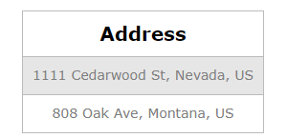

SELECT SUM(Appointment.Cost) AS Total_Cost

FROM Appointment

WHERE Appointment.Patient_ID = 12527

AND Appointment.Date >= DATE_SUB(CURDATE(), INTERVAL 3 YEAR);

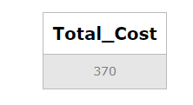

select *

from Doctor

where name='Dr. Israa';

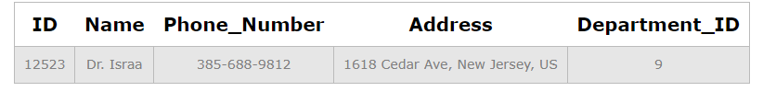

select *

from Appointment;

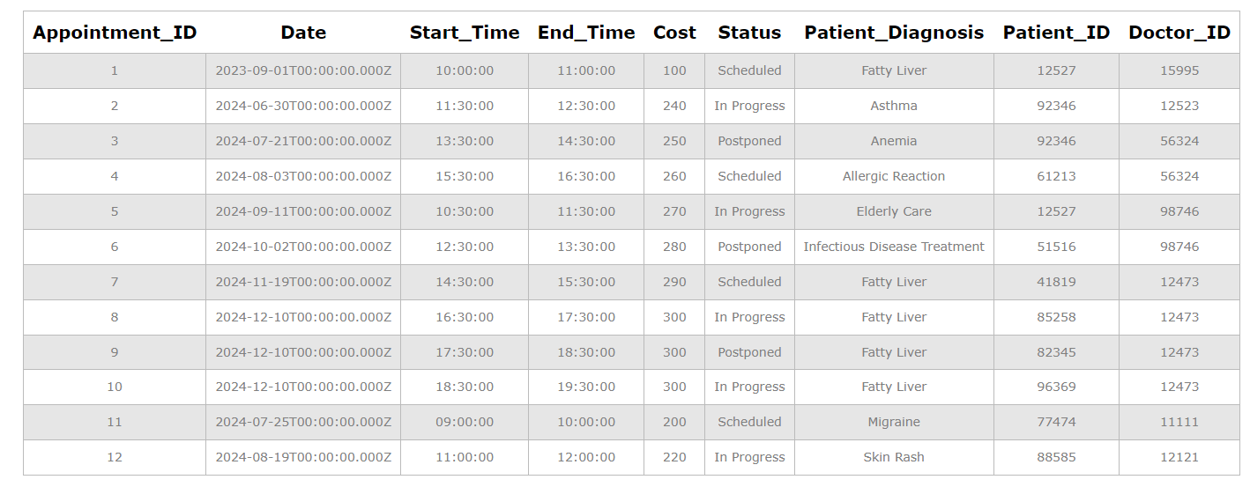

SELECT *

from Patient;

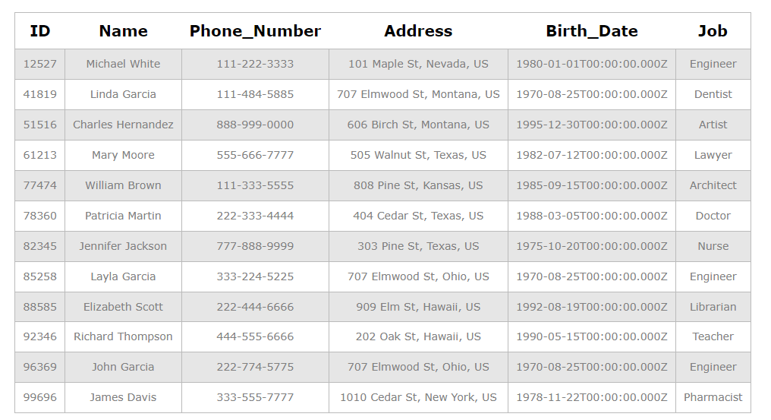

SELECT Address

FROM Doctor

WHERE Address LIKE '% New York, US';

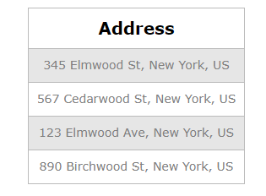

SELECT Address

FROM Doctor

WHERE Address LIKE '% Hawaii, %';

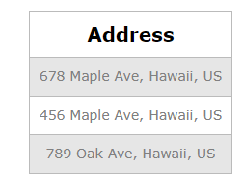

SELECT Doctor.name

FROM Doctor

JOIN Department ON Doctor.Department_ID = Department.ID

WHERE Department.ID = 9;

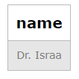

select Appointment_ID,Status,Patient_Diagnosis

from Appointment

where Status='Postponed';

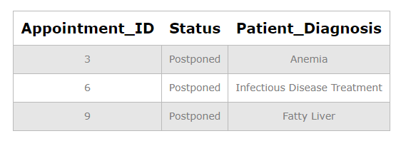

SELECT Max(Cost) As Maximum_Cost

from Appointment;

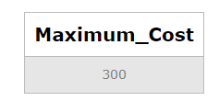

SELECT Min(Cost) Minimum_Cost

from Appointment;

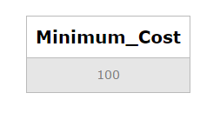

select * from Doctor;

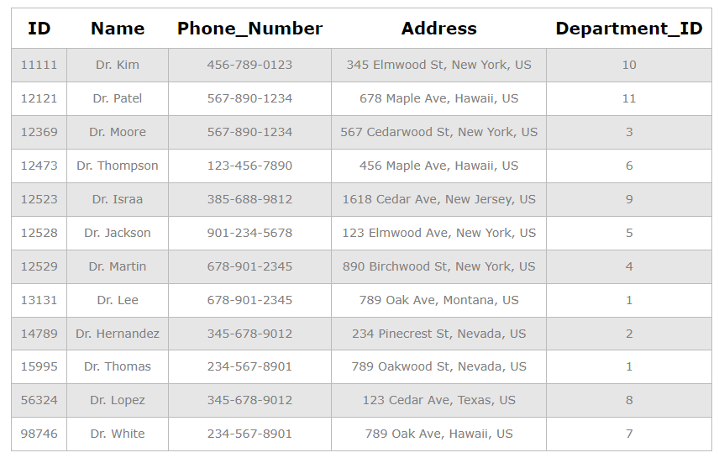

select *

from Doctor

order by name asc;

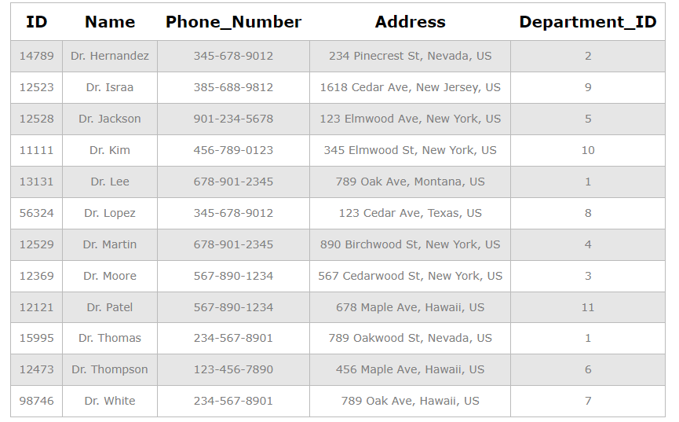

UPDATE Doctor

SET Phone_Number = '555-999-8888'

WHERE ID = 12523;

select *

from Doctor;

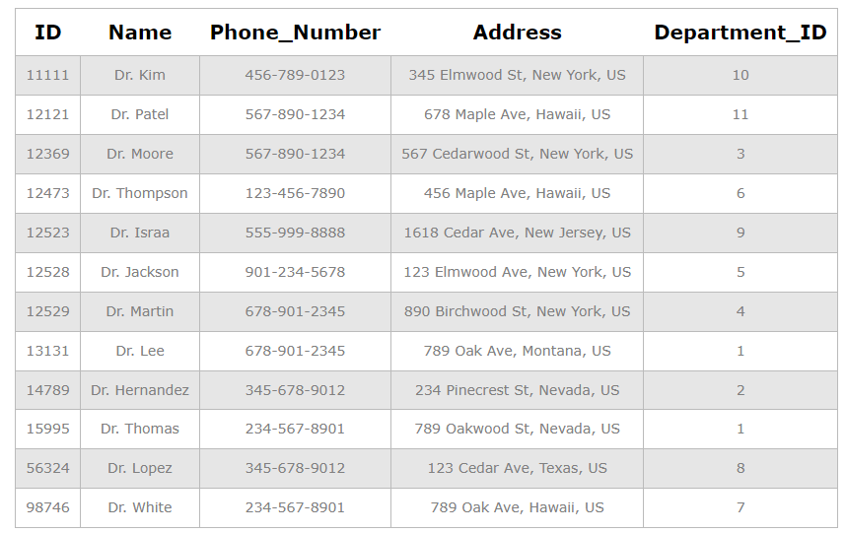

drop table Clinic;